RAG
30.06.2025

RAG (Retrieval - Augmented Generation)
RAG (Retrieval-Augmented Generation) is an AI technique that enhances language models by retrieving relevant information from external sources and using it to generate more accurate and informed responses.

Why we need RAG :
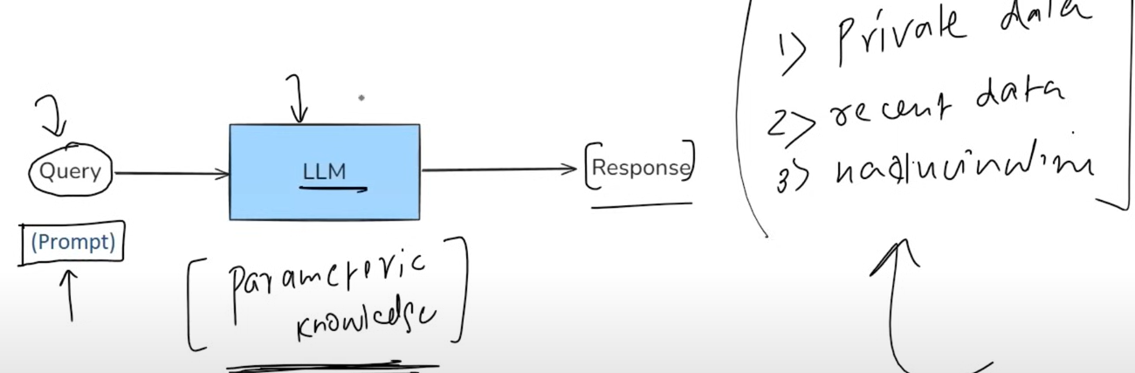
We have concluded that LLM lacks in 3 conditions when we query about :
Private data , recent data and Factual tricky questions.

We find a solution to it as Fine tuning but the problem is how long we did fine tuning when new data is going on generating very fastly .
Fine tuning can be like :
Labelled fine tuning {prompt : desired output} , feeding 1000s rows like this to make the model understand.
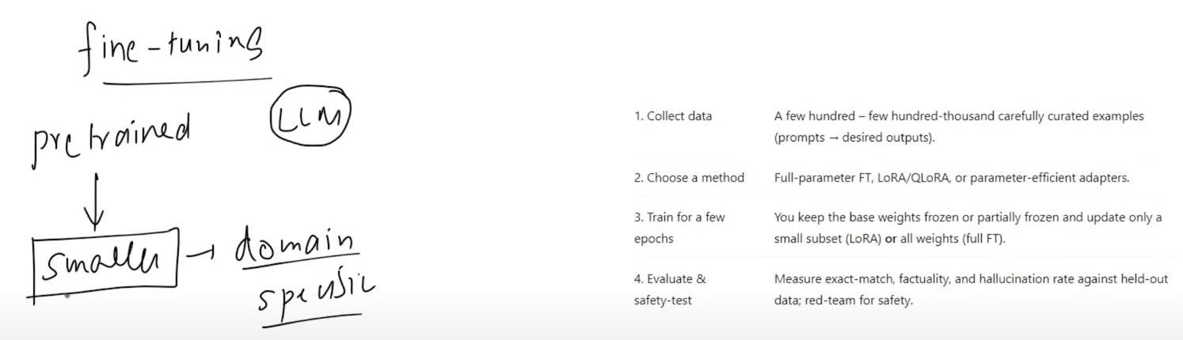

Then comes the point of In-Context Learning : a core capability of LLMs like GPT- 3 / 4 , Claude and Llama where the model learns to solve a task purely by seeing examples in the prompt - without updating its weights.
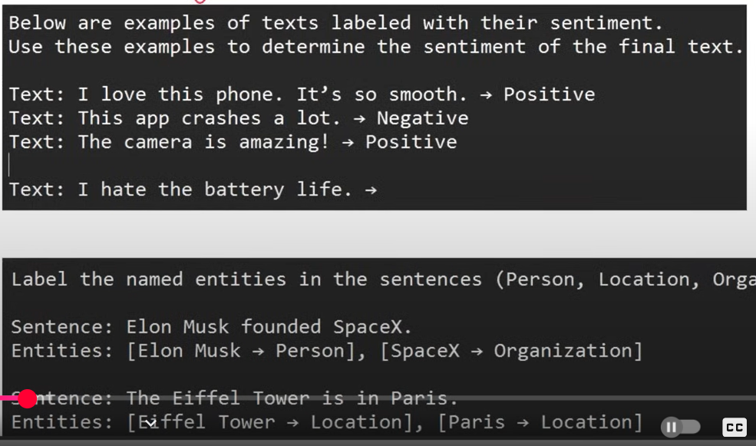
This is because of the Emergent Property : a behavior or ability that suddenly appears in a system when it reaches a certain scale or complexity. That’s why it is found in GPT3 / 4 instead of GPT1 / 2.

What is RAG :
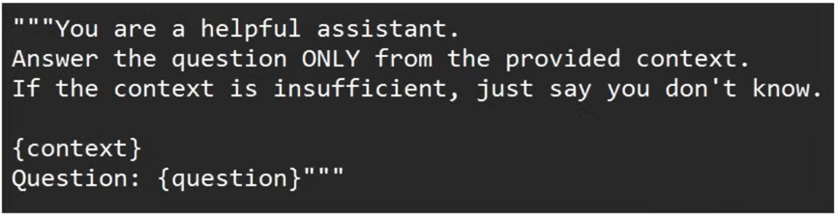
This Finally leads to RAG that serves the concept that Instead of just example tasks , facts inject that into the prompt to augment the model’s knowledge. RAG is a way to make a LLM smarter by giving it extra information at the time you ask your question.
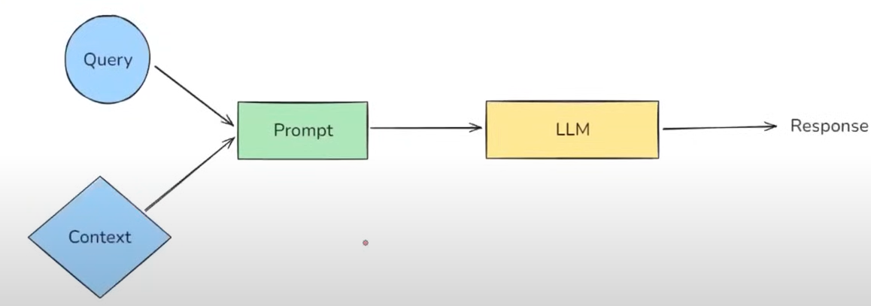

How RAG works :
RAG is composed of two concepts: “Information Retrieval” and “Text Generation”.
Query
Context
prompt
LLM
Extra Knowledge Base
Response
1. Indexing
2. Retrieval
3. Augmentation
4. Generation
RAG

RAG consist of 4 Steps 👍
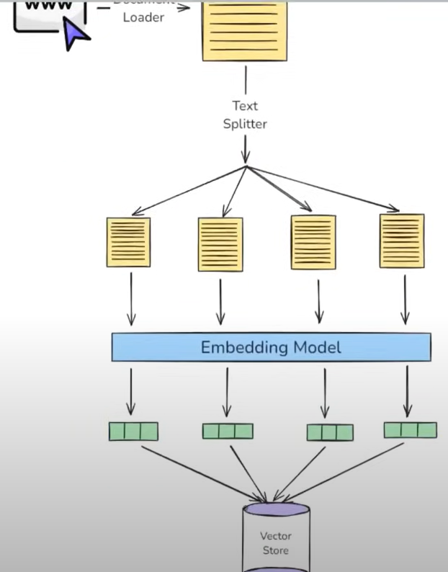
- Indexing : preparing your knowledge base so that it can be efficiently searched at query time.
- Document loader : load your source knowledge in memory.

- Text Chunking : break large documents into small , semantically meaningful chunks.

- Embedding generation : convert each chunk into a dense vector (embedding)

- Storage in a Vector Store : store these vectors along with original chunk text + metadata in a vector database.

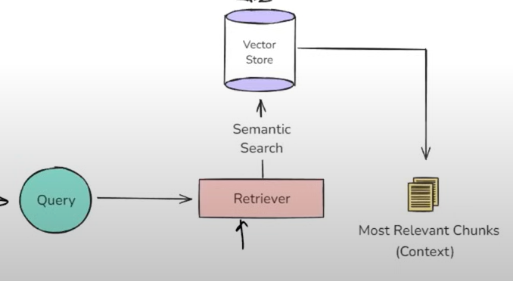
- Retrieval : Real time process of finding the most relevant pieces of information from a pre-built index.
- Query converted to embedding vector
- Semantic searching
- Ranking of responses
- Fetch Top-k results i.e. context formed.

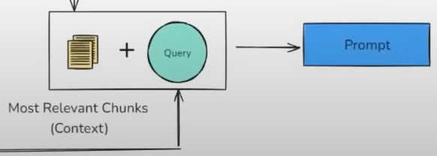
- Augmentation : the step where the retrieved documents (chunks of relevant context) are combined with the user’s query to form a new enriched prompt for LLM.

- Generation : the final step where a LLM uses the user’s query and retrieves an augmented context to generate a response.
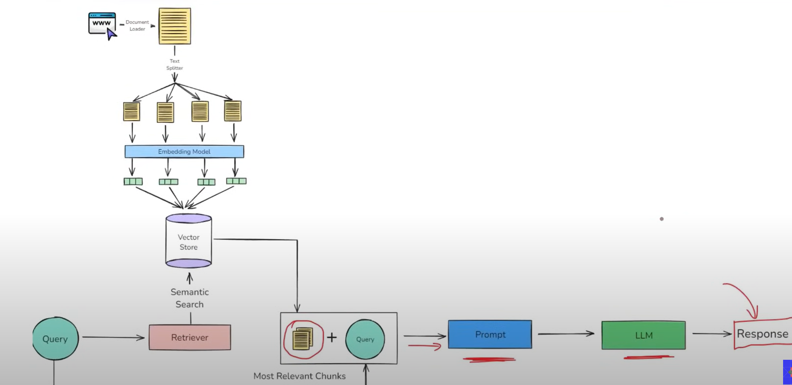

It solves all the 3 problems . Private data and recent data can be loaded from different sources and added up to the vector store so that it can generate responses on them .
Avoid Hallucination as we already mention about this in prompt.

